**LabSheet 11**

creating Spring application to implement all the CRUD operations on the following Student table. using eclipse IDE.

Problem Statement : CRUD operations on the Student table using Spring Boot.

# Creating a Spring Boot Project

Following are the steps to create a simple Spring Boot Project.

## **Step 1:**  created Student table in TEST database. Also make sure your MySQL server is working fine and you have read/write access on the database using the give username and password.

## CREATE TABLE Student(

ID INT NOT NULL AUTO_INCREMENT,

NAME VARCHAR(20) NOT NULL,

AGE INT NOT NULL,

PRIMARY KEY (ID)

);

## **Step 2:** Create a Java project with a name *SpringJdbcEx* and create a package *com.pu* under the src folder in the created project.

## Step 3: Add required Spring libraries using *Add External JARs*.

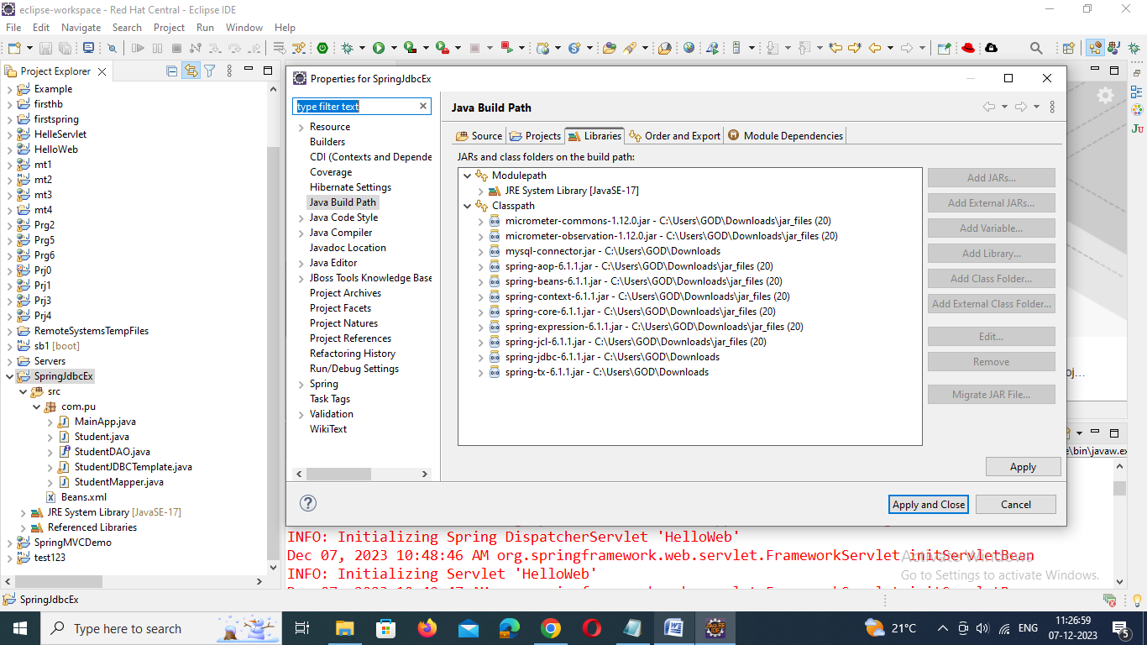

Step 4: Add Spring JDBC specific latest libraries **mysql-connector-java.jar**, **org.springframework.jdbc.jar** and **org.springframework.transaction.jar** in the project. You can download required libraries if you do not have them already.

Step5: Create DAO interface *StudentDAO* and list down all the required methods. Though it is not required and you can directly write *StudentJDBCTemplate* class, but as a good practice, let's do it.

Step 6: Create other required Java classes *Student*, *StudentMapper*, *StudentJDBCTemplate* and *MainApp* under the *com.tutorialspoint* package.

**StudentDAO.java**

package com.tutorialspoint;

import java.util.List;

import javax.sql.DataSource;

public interface StudentDAO {

/**

* This is the method to be used to initialize

* database resources ie. connection.

*/

public void setDataSource(DataSource ds);

/**

* This is the method to be used to create

* a record in the Student table.

*/

public void create(String name, Integer age);

/**

* This is the method to be used to list down

* a record from the Student table corresponding

* to a passed student id.

*/

public Student getStudent(Integer id);

/**

* This is the method to be used to list down

* all the records from the Student table.

*/

public List<Student> listStudents();

/**

* This is the method to be used to delete

* a record from the Student table corresponding

* to a passed student id.

*/

public void delete(Integer id);

/**

* This is the method to be used to update

* a record into the Student table.

*/

public void update(Integer id, Integer age);

}

**Student.java**

package com.pu;

public class Student {

private Integer age;

private String name;

private Integer id;

public void setAge(Integer age) {

this.age = age;

}

public Integer getAge() {

return age;

}

public void setName(String name) {

this.name = name;

}

public String getName() {

return name;

}

public void setId(Integer id) {

this.id = id;

}

public Integer getId() {

return id;

}

}

**StudentMapper.java**

package com.pu;

import java.sql.ResultSet;

import java.sql.SQLException;

import org.springframework.jdbc.core.RowMapper;

public class StudentMapper implements RowMapper<Student> {

public Student mapRow(ResultSet rs, int rowNum) throws SQLException {

Student student = new Student();

student.setId(rs.getInt("id"));

student.setName(rs.getString("name"));

student.setAge(rs.getInt("age"));

return student;

}

}

**StudentJDBCTemplate.java**

package com.pu;

import java.util.List;

import javax.sql.DataSource;

import org.springframework.jdbc.core.JdbcTemplate;

public class StudentJDBCTemplate implements StudentDAO {

private DataSource dataSource;

private JdbcTemplate jdbcTemplateObject;

public void setDataSource(DataSource dataSource) {

this.dataSource = dataSource;

this.jdbcTemplateObject = new JdbcTemplate(dataSource);

}

public void create(String name, Integer age) {

String SQL = "insert into Student (name, age) values (?, ?)";

jdbcTemplateObject.update( SQL, name, age);

System.out.println("Created Record Name = " + name + " Age = " + age);

return;

}

public Student getStudent(Integer id) {

String SQL = "select * from Student where id = ?";

Student student = jdbcTemplateObject.queryForObject(SQL,

new Object[]{id}, new StudentMapper());

return student;

}

public List<Student> listStudents() {

String SQL = "select * from Student";

List <Student> students = jdbcTemplateObject.query(SQL, new StudentMapper());

return students;

}

public void delete(Integer id) {

String SQL = "delete from Student where id = ?";

jdbcTemplateObject.update(SQL, id);

System.out.println("Deleted Record with ID = " + id );

return;

}

public void update(Integer id, Integer age){

String SQL = "update Student set age = ? where id = ?";

jdbcTemplateObject.update(SQL, age, id);

System.out.println("Updated Record with ID = " + id );

return;

}

}

**MainApp.java**

package com.pu;

import java.util.List;

import org.springframework.context.ApplicationContext;

import org.springframework.context.support.ClassPathXmlApplicationContext;

import com.tutorialspoint.StudentJDBCTemplate;

public class MainApp {

public static void main(String[] args) {

ApplicationContext context = new ClassPathXmlApplicationContext("Beans.xml");

StudentJDBCTemplate studentJDBCTemplate =

(StudentJDBCTemplate)context.getBean("studentJDBCTemplate");

System.out.println("------Records Creation--------" );

studentJDBCTemplate.create("Zara", 11);

studentJDBCTemplate.create("Nuha", 2);

studentJDBCTemplate.create("Ayan", 15);

System.out.println("------Listing Multiple Records--------" );

List<Student> students = studentJDBCTemplate.listStudents();

for (Student record : students) {

System.out.print("ID : " + record.getId() );

System.out.print(", Name : " + record.getName() );

System.out.println(", Age : " + record.getAge());

}

System.out.println("----Updating Record with ID = 2 -----" );

studentJDBCTemplate.update(2, 20);

System.out.println("----Listing Record with ID = 2 -----" );

Student student = studentJDBCTemplate.getStudent(2);

System.out.print("ID : " + student.getId() );

System.out.print(", Name : " + student.getName() );

System.out.println(", Age : " + student.getAge());

}

}

Step 7: Create Beans configuration file *Beans.xml* under the **src** folder.

**Beans.xml**

<?xml version = "1.0" encoding = "UTF-8"?>

<beans xmlns = "http://www.springframework.org/schema/beans"

xmlns:xsi = "http://www.w3.org/2001/XMLSchema-instance"

xsi:schemaLocation = "http://www.springframework.org/schema/beans

http://www.springframework.org/schema/beans/spring-beans-3.0.xsd ">

<!-- Initialization for data source -->

<bean id="dataSource"

class = "org.springframework.jdbc.datasource.DriverManagerDataSource">

<property name = "driverClassName" value = "com.mysql.jdbc.Driver"/>

<property name = "url" value = "jdbc:mysql://localhost:3306/TEST?characterEncoding=latin1"/>

<property name = "username" value = "root"/>

<property name = "password" value = "password"/>

</bean>

<!-- Definition for studentJDBCTemplate bean -->

<bean id = "studentJDBCTemplate"

class = "com.pu.StudentJDBCTemplate">

<property name = "dataSource" ref = "dataSource" />

</bean>

</beans>

Step 8: to create the content of all the Java files and Bean Configuration file and run the **MainApp.java** application and output is shown below.

------Records Creation--------

Created Record Name = Zara Age = 11

Created Record Name = Nuha Age = 2

Created Record Name = Ayan Age = 15

------Listing Multiple Records--------

ID : 1, Name : Zara, Age : 11

ID : 2, Name : Nuha, Age : 2

ID : 3, Name : Ayan, Age : 15

----Updating Record with ID = 2 -----

Updated Record with ID = 2

----Listing Record with ID = 2 -----

ID : 2, Name : Nuha, Age : 20